**Basic Load Balancer in Azure**

**Perquisites:**

1. ***Azure Account*:** You’ll need an active Azure account. at <https://azure.com/free>
2. **Basic Cloud Knowledge:** Familiarity with fundamental cloud computing concepts.

# Step by Step Guide to Implement:

**Step 1: Create a Resource Group**

* In the Azure Portal, navigate to “Resource groups.”
* Click on “Create resource group” and provide a name and region for the resource group. Click “Review + create” and then “Create” to create the resource group.

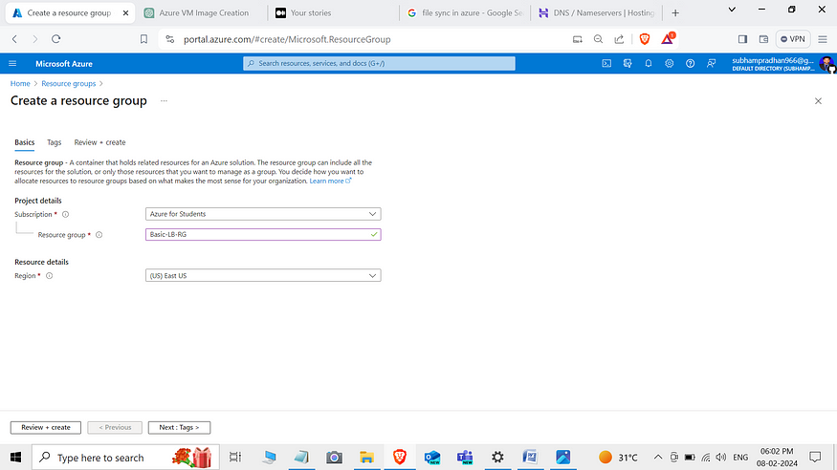

**Step 2: Create Virtual Network**

1. In the Azure portal, navigate to Virtual **Network**.
2. Click on “+ Add” to create a new virtual **Network**.
3. 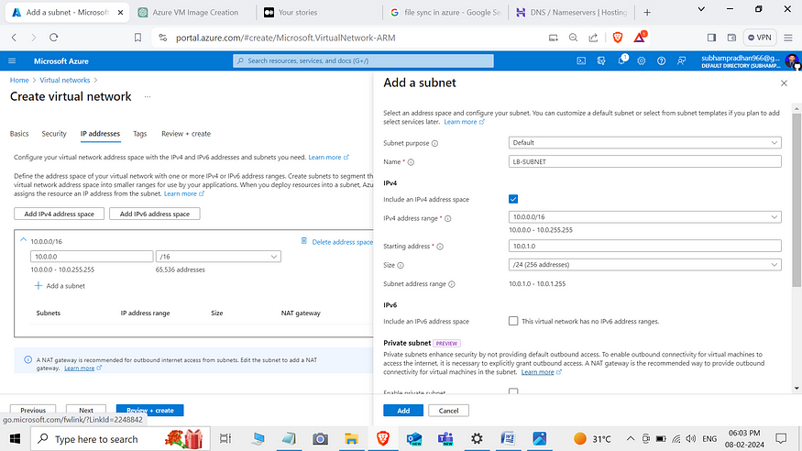Here i created 3 VNet for checking peering connection

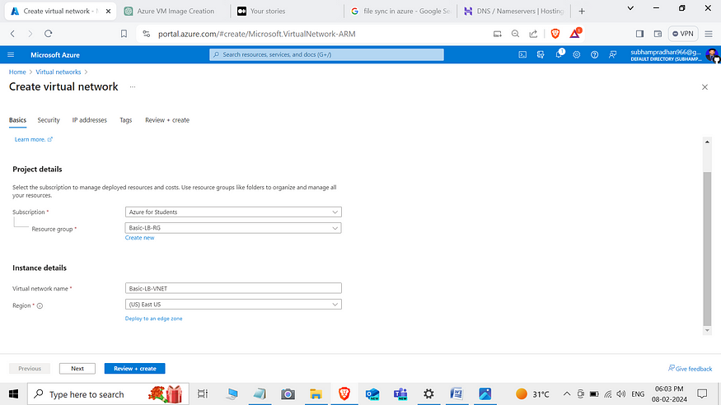

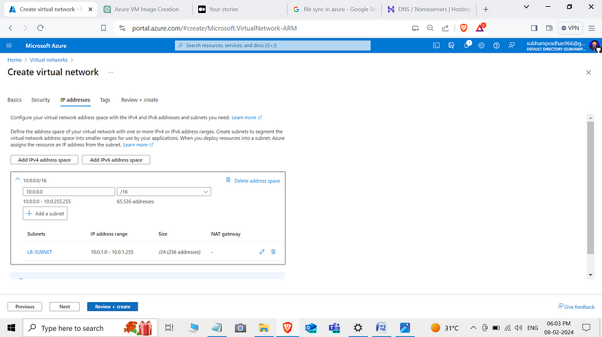

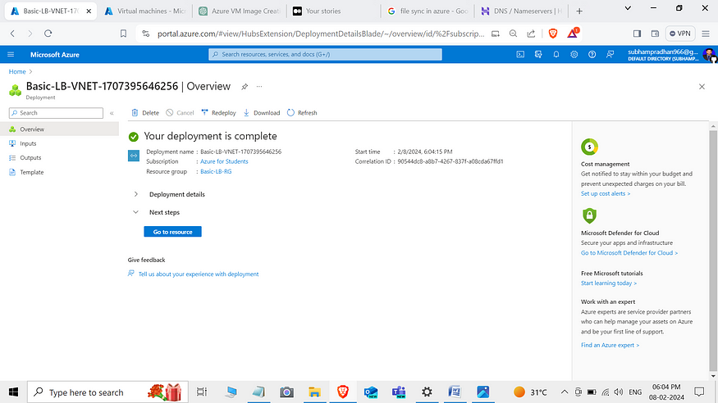

**Step 3: Create Virtual machines**

1. In the Azure portal, navigate to Virtual machines.
2. Click on “+ Add” to create a new virtual machine.
3. Choose the Ubuntu image.
4. Availability option : Availability Set
5. Click “Review + create” and then “Create” to create the virtual machine.

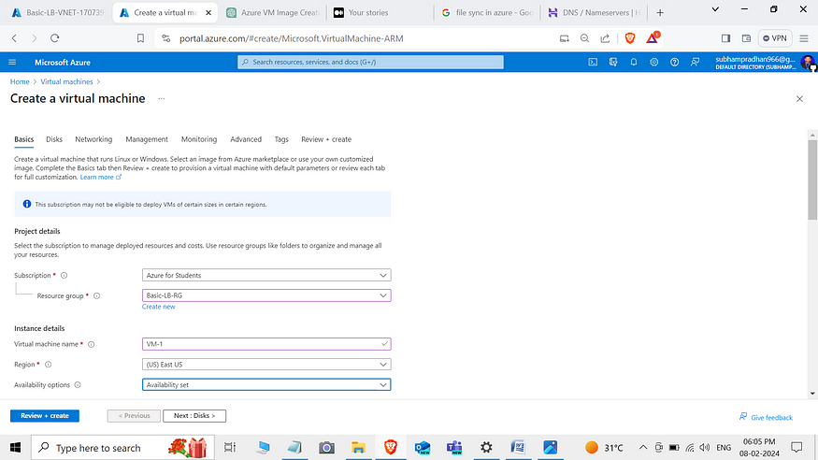

Create Availability Set:

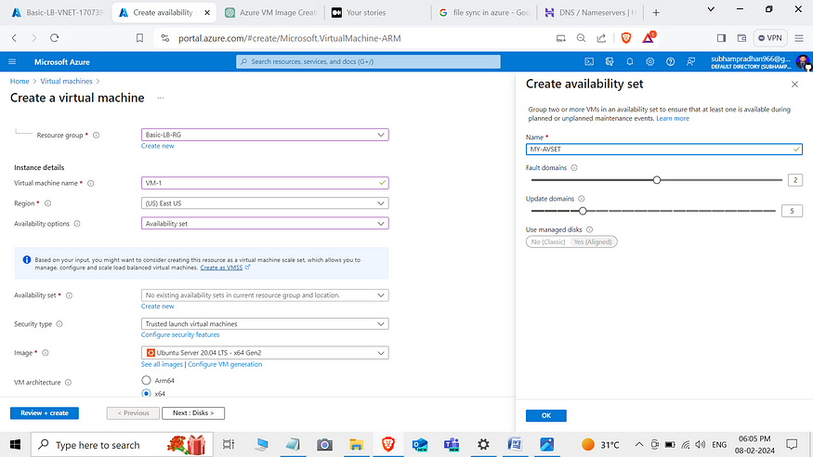

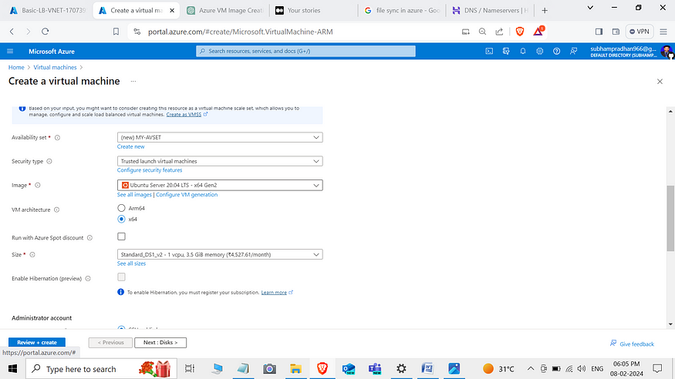

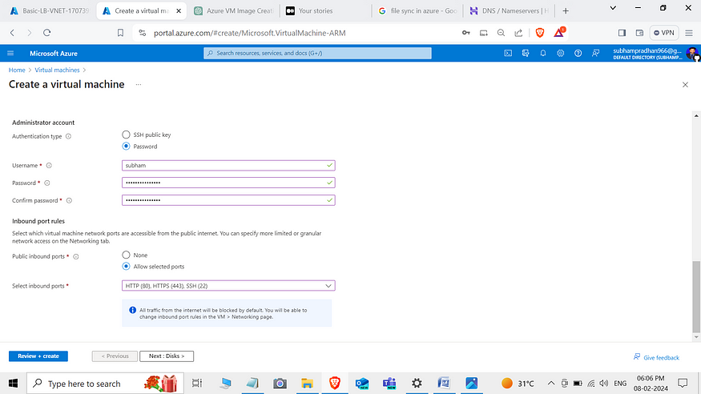

Create public ip address with SKU : Basic and Assignment : Dynamic

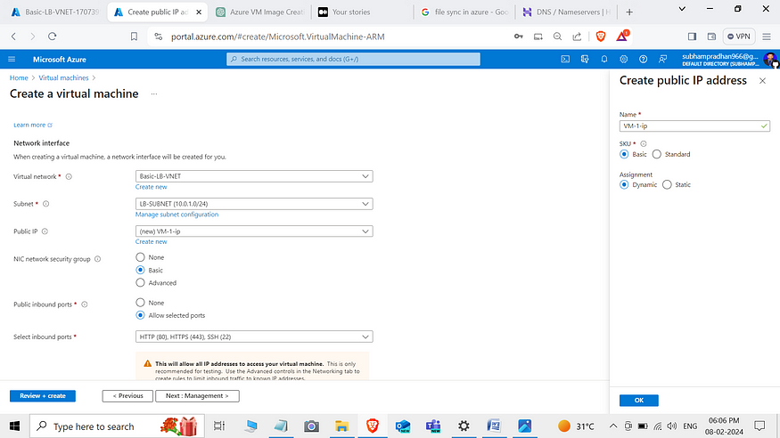

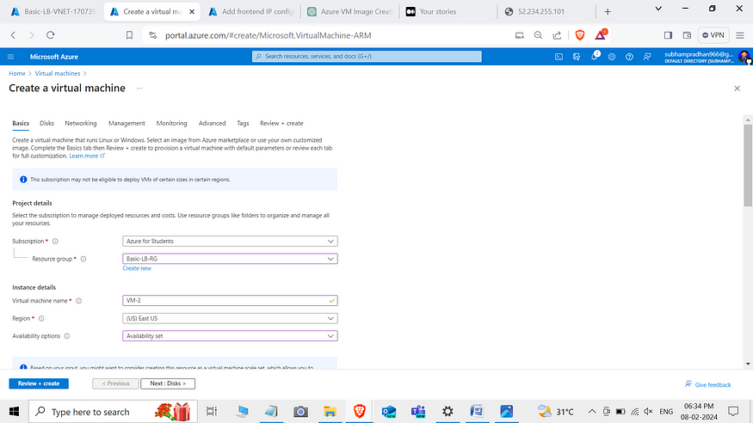

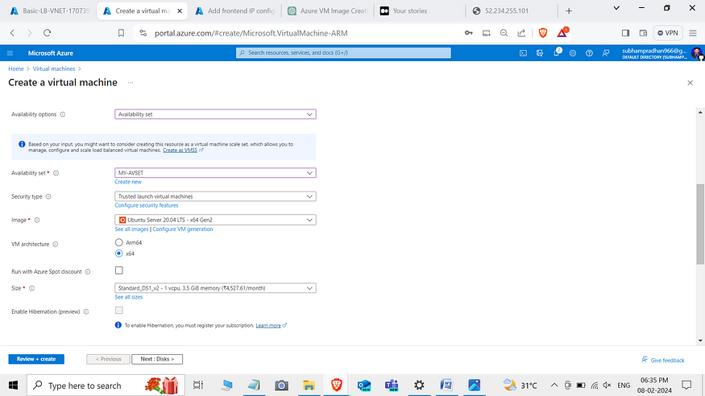

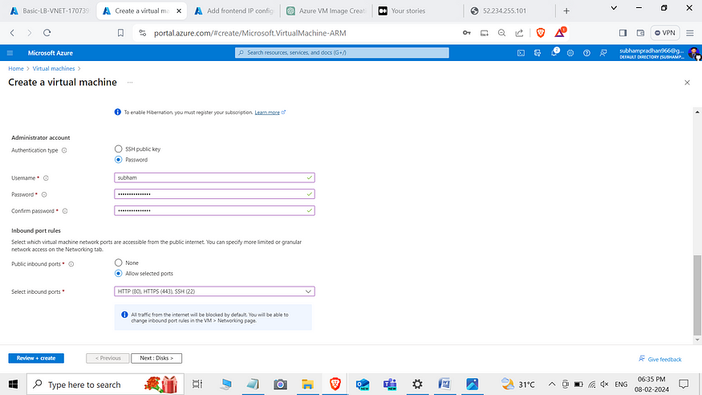

Create another virtual machine with same Availability Set and Create new public ip with SKU : Basic and Assignment : Dynamic

